For IMMEDIATE RELEASE
Contact: Marcus Phillips
Phone: (415) 654-8569
Email: marcus@intermusicsf.org
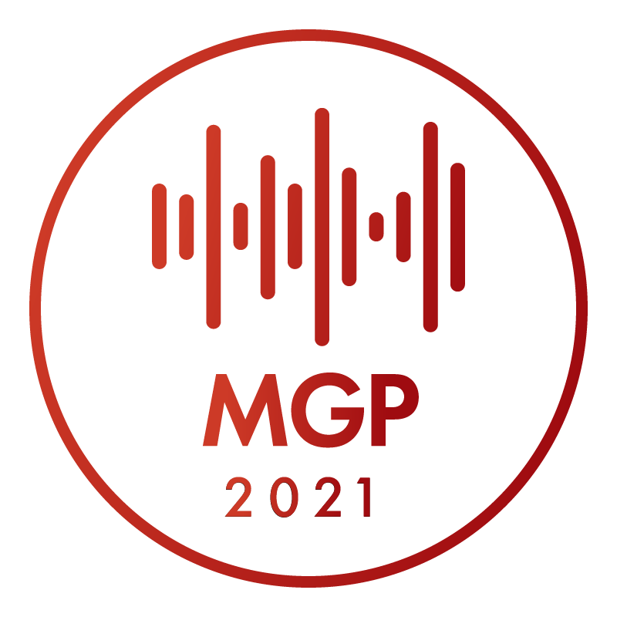
INTERMUSIC SF ANNOUNCES
THE 2021 MUSICAL GRANT PROGRAM RECIPIENTS

June 2nd, 2021 - SAN FRANCISCO— InterMusic SF proudly announces the 29 awardees of this year's Musical Grant Program. The Musical Grant Program (MGP) is a funding initiative designed to support outstanding projects of early music, chamber music, new music, jazz, and creative music in the greater San Francisco Bay Area.

The MGP awards grants through a competitive process to projects that showcase the artistry of local ensembles and enhance the careers of professional musicians. The program aims to foster excellence in the Bay Area’s diverse musical community while cultivating greater access and genuine engagement for new and existing audiences.

Every year, applications are accepted from both emerging and established organizations with budgets below $150,000, including professional small ensembles, composers with collaborating ensembles, and presenting organizations. The MGP is one of a very small number of grants available to this community, and as such plays a crucial role in maintaining cultural opportunities for the public. Now in its 13th cycle, the MGP has proven an extraordinary resource in contributing to the variety and breadth of Northern California’s musical landscape.

In May 2021, the Musical Grant Program awarded grants of up to $3,000 to 29 ensembles, composers, and presenters. The projects described below tell the story of the tremendous diversity and creativity within San Francisco Bay Area's musical community. We extend our deepest gratitude to the San Francisco Grants for the Arts, the Clarence E. Heller Charitable Foundation, the William and Flora Hewlett Foundation, and our many donors for their generosity. In the past 13 cycles since 2008, InterMusic SF (formerly San Francisco Friends of Chamber Music) has awarded $967,000 to help support 328 musical projects in the greater Bay Area.

2021’s MGP Awardees:
(List of Ensembles with genre and brief project descriptions)

African American Composer Initiative – classical, jazz, chamber music, vocal
African American Composer Initiative will present two concerts in January 2022 of music by African American composers, historic and living. Musicians of the AACI join together to present a wide variety of musical genres: spirituals, art songs, vocal and instrumental chamber music in classical and jazz traditions.

Brian Andres Quartet – Latin jazz
Brian Andres Quartet will produce a Latin Jazz recording featuring original compositions and original arrangements culminating in an album release performance.

Ars Minerva – opera, early music, vocal
Ars Minerva will produce Messalina, an opera composed by Carlo Pallavicino in 1679 with a libretto by Francesco Maria Piccioli. The performances will take place November 19-21, 2021 at ODC Theater in San Francisco.

Bay Area Jazz Mobile – jazz, organ
Bay Area Jazz Mobile will present four, free to the public, outdoor jazz concerts in Washington Square Park, San Francisco, on Sunday afternoons from 8/29/21 to 9/19/21. The series, “Bay Area Jazz Mobile B3 Sundays” will feature bands lead by Hammond B3 organ players: Brian Ho, Adam Shulman, Simon Rowe, and B3B4.

Nathan Bickart Trio – jazz, multimedia
Pianist/composer Nathan Bickart will create “Gravity Sweet,” a suite of original compositions for the Nathan Bickart Trio, to be performed in the North and East Bay in Spring 2022. Multimedia materials will accompany the live performance and enhance thematic connections between the material.

George Brooks / Elements Trio – jazz, global
George Brooks and Kala Ramnath will compose three new works for the “Elements Trio” informed by the North Indian tradition of "Haveli Sangeet," an ancient form of devotional music created in praise of nature and Hindu deities, thought to be the precursor of today’s Indian classical music.

CHELLE! Music – spirituals, gospel, jazz, blues
CHELLE! Music will produce “Daughters of the Delta” highlighting the work of African-American women artists during the phenomenon that became known as The Great Migration—how their music related to the emancipation of Black people as they journeyed from the South. “Daughters” will be based on research instigated by Michelle Jacques working with Cava Menzies (with arrangements by Jacques and Bryan Dyer), culminating in four full-length concerts in Oakland and San Francisco by CHELLE & Friends New Orleans Band accompanied by a 10-person community chorus.

Chris Brown / The Chromelodia Project – new music, microtonal, improvised
The Chromelodia Project, will rehearse, premiere, and record Chris Brown’s new, concert-length song cycle “Occhio.” The trio, led by Brown alongside Theresa Wong, cello and voice, and Kyle Bruckmann, oboe and electronics, blends just intonation, improvisation, and interactive computer music.

Ian Dogole – jazz, world
Ian Dogole will produce Quinta Essentia, a recording project featuring original compositions rooted in the traditions of West Africa, Nubia, Afro-Peruvian music and jazz innovators, with fresh interpretations of compositions by legendary jazz masters. Musicians include Sheldon Brown, Richard Howell, Fred Randolph, Sascha Jacobson, David Pinto, Darren Johnston, Frank Martin, with Dogole performing on African, South American and Western percussion instruments.

Earplay – new music, chamber music
Earplay will produce a video performance of Jean Ahn’s Lapis Reprobatus for flute, violin and cello, originally commissioned by Left Coast Chamber Ensemble in 2015.

Atabak Elyasi / Mahsa Vahdat – Persian classical music, vocal
Composer Atabak Elyasi will write a set of songs based on Persian classical and regional music with text from classical and contemporary Persian poetry for vocalist Mahsa Vahdat. The five songs are based on the themes of pain, joy, darkness, light and hope.

Ensemble for These Times / Brennan Stokes – new music, chamber music, vocal
Ensemble for These Times will commission and premiere “The Unseen,” a song cycle by composer Brennan Stokes, setting seven poems by Sara Teasdale. The premiere performance on October 15, 2021 at Old First Concerts, will feature pieces by queer, BIPOC, and women composers as part of “Alchemy,” a concert program exploring new music that transforms old themes, forms, and styles.

Farallon Quintet / Jose Gonzalez Granero – new music, chamber music
Farallon Quintet will commission composer/clarinetist, Jose Gonzalez Granero and record the new work alongside existing works to produce an album of Granero’s music. The commissioned piece will receive its premiere at a CD release concert featuring works on the album.

Mark Fish / The Ledge Trio – new music, chamber music
Mark Fish will compose Indoors, a trio for flute, piano, and double bass to premiere March 2022 by The Ledge Trio at Music at the Mission’s concert series at Old Mission San Jose in Fremont, California.

Electroveesedstene / Ben Goldberg – jazz
Clarinetist Ben Goldberg and trumpeter Andrew Stephens will produce, ELECTROVEESEDSTENE, a project focused on a new approach to the work of jazz great, Charlie Parker.

Motoko Honda / Simple Excesses Quartet – jazz, improvised
Motoko Honda’s “Simple Excesses Quartet” will create new works and further develop existing repertoire composed by Honda through a documented four-concert series in the Bay Area.

Jazz in the Neighborhood – jazz, festival
Jazz in the Neighborhood will produce “Safe Place To Play Festival” a streamed jazz festival with six groups performing for an intimate live audience at the Dresher Ensemble Studio in West Oakland.

Ninth Planet / Assaf Shatil – contemporary chamber music
Ninth Planet will commission composer Assaf Shatil to write “Everyone Became A Trail” a five-movement song cycle for soprano and chamber ensemble, setting poems written by Assaf in response to life during the Covid-19 pandemic. The new work will be performed on October 1, 2021 at Old First Concerts in San Francisco.

Prism Percussion / Nicholas Pavkovic – chamber music
Prism Percussion will commission and record Transit by Nicholas Pavkovic for two percussionists with Pavkovic on keyboard. The premiere performance will take place on YouTube, January 5, 2022.

Persephone Chamber Ensemble – new music, chamber music
Persephone Chamber Ensemble will present a concert program at five venues in the Bay Area, including a newly commissioned work by Hyo-shin Na, Song of Five Friends, for mezzo soprano, violin, viola, cello, and piano. The program will also feature piano quartets and art songs by Romantic women composers Elfrida Andree and Louise Adolpha Le Beau.

Quadre / Jeff Scott – contemporary classical music, vocal
Quadre will premiere “Fair Land Use” by composer Jeff Scott with pianist Jaymes Kirksey and soloists from the Oakland Interfaith Gospel Choir, additionally engaging with local environmental community partners and regional schools delving into improvisatory storytelling. Kristopher Grant and Harumo Sato will create multimedia presentations and set designs respectively for the premiere performance at the Mountain View Center for the Performing Arts on March 27, 2022.

Rent Romus / Life's Blood Ensemble – jazz, improvised
Rent Romus will record a new joint project co-written with composer, educator, and musician Heikki Koskinen entitled “Itkuja” (pronounced it-koo-yaw [lament]), an original music research project knitting the structures of jazz, mythopoetic structures, and free improvisation exploring the connection between oral traditions and healing practices of the lament from the north and eastern regions of Finno-Ugric cultures. The recording will be completed by Romus’ Life’s Blood Ensemble and augmented by traditional and invented instruments such as free-reeds, overtone flutes, voice, strings, and the Finnish kantele.

Rova Saxophone Quartet – new music, improvised
Rova Saxophone Quartet will complete a recording project developed through several exploratory recording sessions leading to a radically new re-imagining of the possibilities of saxophone-based sonic exploration.

Gaea Schell Quartet – jazz
Pianist/flutist Gaea Schell will compose and record five new works for the Gaea Schell Quartet, producing a new EP with guest musicians combining elements of mainstream, Latin jazz, and classical genres.

John Schott / William Winant Percussion Ensemble – new music
Guitarist, John Schott will compose a Concerto for Electric Guitar and Percussion Ensemble for the William Winant Percussion Ensemble. The piece, positions the electric guitar as a virtuoso protagonist of mercurial personalities, supported and challenged by five percussionists playing a veritable orchestra of drums, gongs, metal objects, xylophone, glockenspiel and a specially tuned electric bass played as a percussion instrument with sticks and a bow.

Sierra Ensemble / Richard Aldag – new music, chamber music
Sierra Ensemble will commission Richard Aldag to compose a new trio to be premiered at Old First Church in Spring 2022.

Telegraph Quartet – chamber music
Telegraph Quartet will produce TeleLab, a performance series across the Bay Area aiming to create an exploratory experience for audiences focusing on the inner workings of a single chamber work, presenting the musical and emotional aspects of an entire work by one composer culminating in a full performance.

Trio Solano / Dan Flanagan – new music, chamber music
Trio Solano will record a video of Dan Flanagan’s composition, “Ehrlichia, Rhapsody in Discomfort #6.” The piece’s title refers to one of the many tick-borne diseases under the umbrella of Lyme Disease, which is the thematic focus of the piece. Artist, Nancy Schroeder will make a painting inspired by this piece, which will be featured in the video during the performance.

Vitamin Em – jazz, funk, fusion, classical
Vitamin Em members Paul Hanson, Evan Price and Emily Onderdonk will collaborate on a Triptych/Trio of new acoustic and electroacoustic works which highlight improvisation across several genres including classical, jazz, funk, acid jazz and fusion. The new work will be premiered in a filmed and recorded performance at St. Alban’s Church in Albany, CA in October 2021.

### END###
Link to Press Photos: https://www.intermusicsf.org/press-page/
Link to Website: https://www.intermusicsf.org/musical-grant-program/
For more information on the Musical Grant Program please contact marcus@intermusicsf.org

