For IMMEDIATE RELEASE
Contact: Marcus Phillips
Phone: (415) 654-8569
Email: marcus@intermusicsf.org
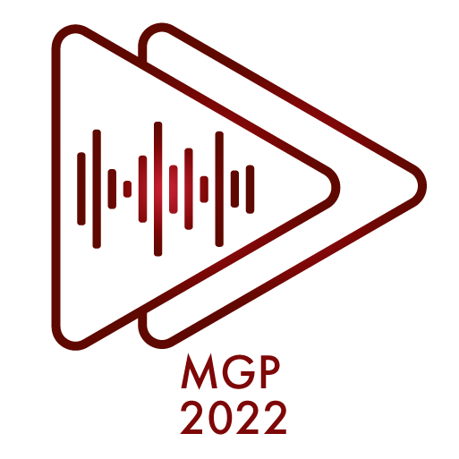
INTERMUSIC SF ANNOUNCES
THE 2022 MUSICAL GRANT PROGRAM RECIPIENTS

July 18th, 2022 - SAN FRANCISCO— InterMusic SF proudly announces the 21 recipients of this year's Musical Grant Program. The Musical Grant Program (MGP) is a funding initiative designed to support outstanding projects of early music, chamber music, new music, jazz, and creative music in the greater San Francisco Bay Area.

The MGP awards grants through a competitive process to projects that showcase the artistry of local ensembles and enhance the careers of professional musicians. The program aims to foster excellence in the Bay Area’s diverse musical community while cultivating greater access and genuine engagement for new and existing audiences.

Every year, applications are accepted from both emerging and established organizations with budgets below $150,000, including professional small ensembles, composers with collaborating ensembles, and presenting organizations. The MGP is one of a very small number of grants available to this community, and as such plays a crucial role in maintaining cultural opportunities for the public. Now in its 14th cycle, the MGP has proven an extraordinary resource in contributing to the variety and breadth of Northern California’s musical landscape.

In July 2022, the Musical Grant Program awarded grants of up to $3,000 to 21 ensembles, composers, and presenters. The projects described below tell the story of the tremendous diversity and creativity within San Francisco Bay Area's musical community. We extend our deepest gratitude to the Clarence E. Heller Charitable Foundation, the William and Flora Hewlett Foundation, and our many donors for their generosity. Since 2008, InterMusic SF has awarded $1,024,000 to help support 339 musical projects.

MGP 2022 Awardees:
(List of Ensembles with genre and brief project descriptions)

Florante Aguilar & Cascada de Flores — traditional Filipino and Mexican
Florante Aguilar and Cascada de Flores will collaborate on a performance and recording featuring original and traditional songs from the Philippines and Mexico highlighting the musical commonalities and connections between these two former colonial subjects of Spain.

Amateur Music Network — jazz
Amateur Music Network’s Making Music with Destiny Muhammad project will be a two-hour hybrid in-person/online program with the Destiny Muhammad Trio at Little Mission Studio in San Francisco, September 2022.

The Bernal Hill Players — contemporary chamber music
The Bernal Hill Players will present “Forces of Nature,” a program of contemporary music premiering a new composition by Jennifer Peringer alongside two commissioned works by Davide Verotta and Sarah Stiles. The program will be performed in spring 2023 at Old First Concerts, Piedmont Center for the Arts, and the Center for New Music.

Brett Carson — New Music
Brett Carson will premiere “The Secret Life of the Paramecium,” a new song cycle to be performed by the quartet Paramecia Occulta, consisting of Amy Foote (soprano), Michelle Lee (flutes), Joshua Marshall (saxophones), and Ramon Fermin (electric guitar).

Carnatic Crossings — contemporary, Indian classical
Carnatic Crossings, led by Sruti Sarathy (Indian classical violin, vocals) and Rohan Krishnamurthy (mridangam, multi-percussion) will compose and record new compositions which capture the sound of the South Asian diaspora in the Bay Area. The new repertoire will feature chants, spoken word, and oral recordings, in addition to Carnatic ragas and rhythms, to be released as a debut EP in Fall 2023.

Sandy Cressman and Homenagem Brasileira — jazz
Sandy Cressman and Homenagem Brasileira will record a new CD, "Cantos do Povo - The Music of Milton Nascimento," exploring Nascimento's body of work which celebrates working people and gives voice to resistance to political oppression. The recording features original arrangements and new compositions inspired by Nascimento’s music and by our current social and political climate.

The Dynamic Miss Faye Carol & Her Sextet — jazz
The Dynamic Miss Faye Carol will construct a new 90-minute suite of music entitled “Black Music Through The Ages" consisting of 12 pieces exploring jazz, blues, R&B, gospel, and hip-hop from the early 20th century to the present day. In celebration of Black History Month, the event will welcome youth, seniors, low-income and disadvantaged populations to Oakland's historic Black venue, Geoffrey's Inner Circle.

Ensemble ARI / Jungyoon Wie — classical, contemporary
Ensemble ARI will commission Jungyoon Wie to compose a new piano trio for a concert highlighting Asian composers in May, 2023 at St. Mary’s College, Moraga. The program features pieces by contemporary Asian composers and arrangements of Korean folk songs.

Ensemble Mik Nawooj / JooWan Kim — hip-hop, electronic, contemporary
Ensemble Mik Nawooj will present the US premiere of Hip-Hop Orchestra Experience (HHOE) by composer JooWan Kim, Nov 10, 2022 at the San Francisco Asian Art Museum in Samsung Hall.
musicians Corey Jamason (organ), Elisabeth Reed (cello), and Owen Dalby (violin), as well as the early music ensemble Ruckus, and oboist Debra Nagy.

The Living Earth Show / Sharmi Basu — New Music
Sharmi Basu will compose “Boundaried,” a concert-length work for guitar, percussion, and electronics to be performed and recorded by The Living Earth Show with Basu performing on electronics and released as an album on Earthy Records in 2023.

Lisa Mezzacappa — jazz
Lisa Mezzacappa will compose and produce two final episodes of “The Electronic Lover,” a new audio opera with librettist Beth Lisick. The nine-episode opera has been released as a serial podcast since summer 2020. The final episodes will premiere in winter and spring 2023.

Mo'Fone — jazz
Mo’Fone will record and produce their fourth full-length album featuring compositions by all three members, Jeremy Steinkoler, Larry De La Cruz, Jim Peterson, culminating in an album release performance.

Nash Baroque — early music, dance
Nash Baroque will collaborate with Dance Through Time on performances of Italian baroque music, dance, and pantomime of the 18th-century Italian theater in May of 2023 at St. Mark’s Lutheran Church, San Francisco and St. Mark’s Episcopal Church, Berkeley.

Nicholas Phan Recording Projects — classical, vocal
Tenor Nicholas Phan will perform, record & film fourteen tenor arias by Johann Sebastian Bach in venues around San Francisco. Videos will be released as part of a weekly podcast, featuring interviews with musicians, Bach scholars, and audience members. Collaborators for these films will include SF-based

Quinteto Latino / Carla Lucero — New Music
Quinteto Latino will commission composer/librettist Carla Lucero to write a work for wind quintet and voices with 21V, documenting the lives of long time SF Bay Area Chicana activists, labor leader Dolores

About InterMusic SF
InterMusic SF is a San Francisco Bay Area non-profit organization that advocates for those who create, share, and love the art of small ensemble music. InterMusic SF acts as a catalyst to help local artists thrive via career development and creative collaboration.

Calendar Editors Please Note:

InterMusic SF Announces

What: 2022’s Musical Grant Program Recipients

Description: InterMusic SF proudly announces the 21 awardees of this year's Musical Grant Program. The Musical Grant Program (MGP) is a funding initiative designed to support outstanding projects of early music, chamber music, new music, jazz, and creative music in the greater San Francisco Bay Area.

Information: For more information visit https://www.intermusicsf.org/musical-grant-program/

### END###
Link to Press Photos: https://www.intermusicsf.org/press-page/
Link to Website: https://www.intermusicsf.org/musical-grant-program/
For more information on the Musical Grant Program please contact marcus@intermusicsf.org

