For IMMEDIATE RELEASE
Contact: Marcus Phillips
Phone: (415) 654-8569
Email: marcus@intermusicsf.org
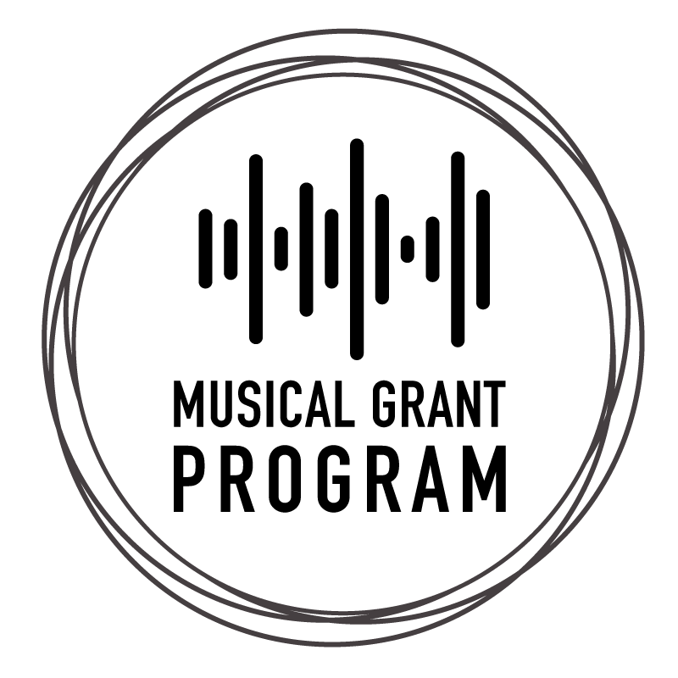
PRESS RELEASE
The InterMusic SF 2024 Musical Grant Program
The Musical Grant Program 2024 Application Cycle is now open.
Open call to individual artists and arts & culture organizations.

The InterMusic SF Musical Grant Program (MGP) is an annual project grant opportunity open to Bay Area-based musicians, artists, and organizations. The MGP aims to promote musical activities through the support of small ensembles, instrumental and vocal performers, composers, concert presenters, arts & culture organizations, and artistic collaborations. Eligible projects include concerts, recordings, commissions, and short-duration festivals.

Maximum Award: $3,000, single entity-led projects; $4,000, collaborative projects
Notification: Awards will be announced in late May 2024
Grant Activity Period: June 1, 2024 - December 31, 2025
Website: https://www.intermusicsf.org/mgp/
Contact: mgp@intermusicsf.org, (415) 818-2825

MGP Workshop: March 7, 2024
Application Deadline: April 14, 2024, 11:59 PM PT

MGP Workshop + Info Session - FREE
Date: Thu, March 7, 2024, 6:00 PM – 7:00 PM PT

Workshop is optional and FREE. Register on eventbrite.

About the MGP
The mission of the Musical Grant Program (MGP) is to encourage and promote the creation of small ensemble music. The MGP is an annual grant opportunity that provides financial support for Bay Area-based music creators and collaborators committed to the presentation and production of small ensemble music.

Funding
The InterMusic SF Musical Grant Program (MGP) is made possible through support from Clarence E. Heller Foundation, William and Flora Hewlett Foundation, and the generous support of InterMusic SF’s individual donors. In 2008, InterMusic SF developed the MGP and in its 16 year-long history, has awarded over $1.1MM in project funding to local artists. With support from the MGP, musicians continue to offer masterful and groundbreaking contributions to the cultural fabric that defines the Bay Area as a vibrant, creative ecosystem.

Eligible applicants must meet the following requirements:
- Be at least 18 years of age
- Be a U.S. citizen or a legal resident
- Reside and present the project in one of the following nine Greater San Francisco Bay Area counties: Alameda, Contra Costa, Marin, Napa, San Francisco, San Mateo, Santa Clara, Marin, Solano, Sonoma
- Have an annual operational budget of under $150,000

Please visit www.www.intermusicsf.org/mgp for all information about the Musical Grant Program. For assistance contact: mgp@intermusicsf.org.

### END###
Link to Press Photos: http://www.intermusicsf.org/press-room
For more information about the 2024 MGP, please contact marcus@intermusicsf.org.

