FOR IMMEDIATE RELEASE
Contact: Marcus Phillips
Phone: (415) 654-8569
Email: marcus@intermusicsf.org

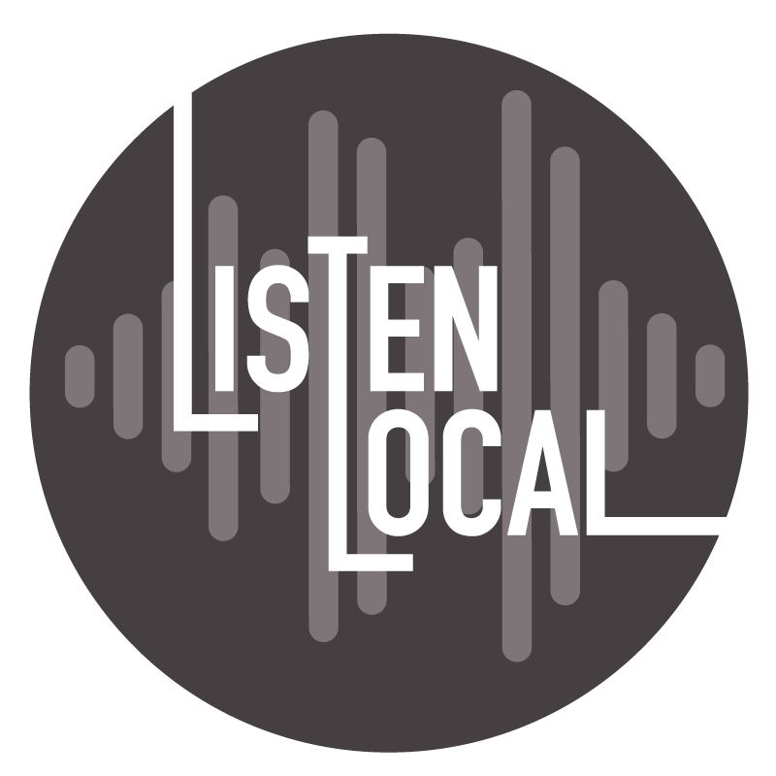

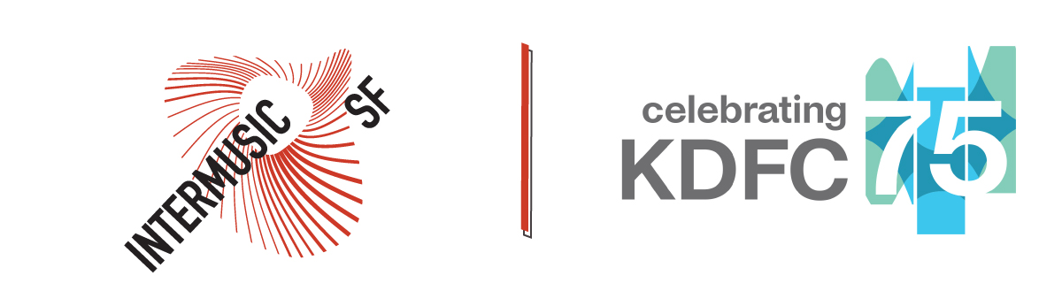

Classical California KDFC + InterMusic SF Present Inaugural Concert Series:
Listen Local

A Free Music Concert Series Showcasing Bay Area Small Ensembles and Soloists

Sunday, March 17
2pm-3:30pm
Sunday, May 19 at 2pm
2pm-3:30pm

The Bowes Performing Arts Center
Cha Chi Ming Recital Hall
200 Van Ness Avenue, San Francisco

San Francisco, CA
www.intermusicsf.org/listenlocal

Listen Local is a new, free concert series presented at the Bowes Performing Arts Center that showcases the best of the Bay Area’s small ensemble musicians and soloists. The musical offering was developed in partnership by Classical California KDFC and InterMusic SF to serve Bay Area communities by connecting listeners to local musicians. Programming will highlight classical, American traditional, and genre-bending artists, providing an opportunity to hear Bay Area masters in an intimate musical setting, admission-free. For more information, visit www.intermusicsf.org/listenlocal.

Listen Local will take place in the Cha Chi Ming Recital Hall at the Bowes Performing Arts Center in San Francisco. The building is an expansion of the San Francisco Conservatory of Music and the home to Classical California KDFC studios. The Bowes Center is easily accessible by public transportation and sits among other SF cultural beacons, such as Davies Symphony Hall and the San Francisco War Memorial and Performing Arts Center.

The Cha Chi Ming Recital Hall has a jewel-box design and features dramatic windows, offering street-level views of Van Ness Avenue. Though Listen Local concerts are admission-free, there will be limited seating to 100 audience members. Attendees are strongly encouraged to reserve tickets for upcoming concerts in advance by visiting www.intermusicsf.org/listenlocal.

The inaugural season of Listen Local will present two concerts: March 17 and May 19.

On Sunday, March 17, Listen Local will present Agave, the GRAMMY-nominated Bay Area ensemble that specializes in string-music of the seventeenth through twentieth centuries, performing as a string quartet featuring Katherine Kyme, Anna Washburn, Aaron Westman, and William Skeen. Their program will exclusively celebrate women composers with works by Fanny Mendelssohn-Hensel, Dora Pejacevic, Claudia Rusca, Clara Schumann, Rosy Wertheim, Margaret Bonds, and Florence Price, inspired by their latest recording effort, AGAVE: In Her Hands.

On Sunday, May 19, experience one of today’s brilliant musical voices, violinist Nancy Zhou. Her thoughtful musicianship resonates with a global audience in such a way that brings her on stage with leading orchestras and chamber musicians around the world. Listen Local will showcase a solo violin recital by Zhou, with a dynamic collection of works that fall both in and outside the traditional canon of classical music by composers J.S. Bach, Eugène Ysaÿe, John Corigliano, Krzysztof Penderecki, and Fritz Kreisler.

Many featured performers of Listen Local are members of InterMusic SF’s Fiscal Sponsorship Program roster or have received funding through the InterMusic SF annual Musical Grant Program. InterMusic SF programs aim to uplift Bay Area-based musicians dedicated to performing, creating, and sharing small ensemble music in our local communities.
Listen Local is only made possible through Classical California’s stead-fast commitment to Bay Area communities of listeners and artists. In partnership with InterMusic SF, Listen Local is a dedicated effort toward increasing access to world-class music for everyone.
Classical California is the most-listened-to network of classical music radio stations in America serving more than 800,000 listeners each week. KUSC, located in downtown Los Angeles, serves communities throughout Southern California and is broadcast on 91.5FM in Los Angeles and Orange County, 88.5FM in Palm Springs, 91.1FM in Thousand Oaks, 93.7FM in Santa Barbara and 99.7FM San Luis Obispo. KDFC, located in downtown San Francisco, serves the Bay area and other communities in Northern California, and is broadcast on 90.3FM in San Francisco, 104.9FM in San Jose, 89.9FM in Napa Wine Country, 103.9FM in Monterey and 92.5FM in Ukiah. Listeners can also hear these stations streaming at kusc.org, kdfc.com, and on their smartphone apps. Classical California also offers a variety of digital content and community events.

Classical California’s mission is to make a positive impact on individuals and communities by championing the power of classical music and is a broadcast service of the University of Southern California.

InterMusic SF serves as a trusted advocate for the arts that is dedicated to nourishing and sustaining the Bay Area creative environment for music creators and audiences.

****

CALENDAR EDITORS PLEASE NOTE:
What: Classical California KDFC + InterMusic SF Present: Listen Local
Description:
Listen Local is a new, free concert series presented in the cultural center of San Francisco, showcasing the best of the Bay Area’s small ensemble musicians and soloists. The musical offering was developed in partnership by Classical California KDFC and InterMusic SF to serve Bay Area communities by connecting listeners to local musicians. Programming will highlight classical, American traditional, and genre-bending artists, providing an opportunity to hear Bay Area masters in an intimate musical setting, admission-free.
Where: The Bowes Center, 200 Van Ness Avenue, San Francisco
When: Sunday, March 17, 2024 at 2pm - 3:30pm
Sunday, May 19, 2024 at 2pm - 3:30pm
Program: March 17: Agave; exclusively celebrating women composers with works by Fanny Mendelssohn-Hensel, Dora Pejacevic, Claudia Rusca, Clara Schumann, Rosy Wertheim, Margaret Bonds, and Florence Price.
May 19: Violinist Nancy Zhou; performing solo works for violin by J.S. Bach, Eugène Ysaÿe, John Corigliano, Krzysztof Penderecki, and Fritz Kreisler.
Tickets: Admission is free; limited tickets available, reservations required.
Information: For information visit www.intermusicsf.org, or call (415) 818-2825.
Classical California, Media Contact: Liza Prijatel Thors, liza@thedooronline.com
InterMusic SF, Media Contact: Marcus Phillips, marcus@intermusicsf.org
#### END####

