### **FOR IMMEDIATE RELEASE**

*Contact: Marcus Phillips*

*Phone: (415) 654-8569*

*Email: marcus@intermusicsf.org*

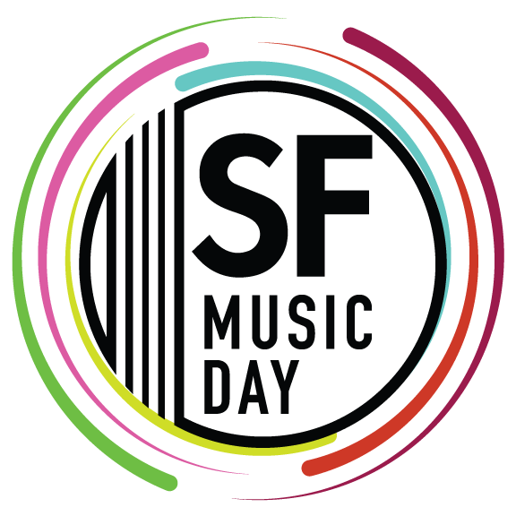

**InterMusic SF Presents 17th Annual SF Music Day on October 20, 2024**

**A Daylong Celebration of Bay Area Music Featuring 80+ Artists, 19 Groups, and Over 7 Hours of Free Performances**

**Sunday, October 20, 2024 | 12:00 PM - 7:00 PM | Free, All-Ages, Family-Friendly**

**San Francisco War Memorial & Performing Arts Center, 401 Van Ness Avenue, San Francisco, CA**

[sfmusicday.com](http://www.sfmusicday.com)

San Francisco, CA—InterMusic SF proudly announces the 17th annual **SF Music Day**, taking place on **Sunday, October 20, 2024,** at the **San Francisco War Memorial & Performing Arts Center**. The free, daylong music festival showcases some of the Bay Area’s most celebrated musicians and artists, offering audiences an extraordinary opportunity to experience world-class live music performances.

Guest-curated by vocalist and performing artist **Sidney Chen**, SF Music Day remains committed to its signature programming of showcasing a broad range of musical traditions. The 2024 lineup features instrumentalists and vocalists, reflecting the rich diversity of the Bay Area’s musical landscape.

Starting at noon, SF Music Day presents **19 local groups**, with over **80 artists** performing for **7+ hours** of continuous music. Audiences will be treated to an array of genres, including blues, chamber-folk, classical, early, experimental, jazz, new, tango, world music, and blended genres. Throughout the day, concert-goers are invited to explore a culturally rich festival that showcases the vibrant diversity and brilliant artistry that defines the Bay Area music scene.

**For more information, visit** [**sfmusicday.com**](http://sfmusicday.com).

SF Music Day is open to all, with flexible entry and exit during performances, making it ideal for families and attendees of all ages. The event takes place across multiple stages at the War Memorial, allowing for a dynamic and immersive experience.

For the first time ever, SF Music Day offers **livestream broadcasts** on two channels, featuring full coverage of performances from the **Herbst Theatre** and the **Green Room**, extending the event’s reach to global audiences.

**Exclusive Performances and One-Time-Only Events**

SF Music Day 2024 features several exclusive, one-time-only performances. Featured artists include:

**Beneath A Tree with Kjell Nordeson**

**Beth Schenck Quintet**

**Bethany Hill**

**Chelsea Hollow + Taylor Chan**

**Choi-Lee-Teicholz Trio**

**Circadian String Quartet**

**Diana Gameros + Patrick Wolff**

**Geechi Taylor Quintet**

**Kyle Tingzon + Benjamin Liupaogo**

**Liu Xi 柳溪 Willow Stream**

**Manik Khan & Arjun K. Verma with Eman Hashimi**

**Oakland School for the Arts: Jazz Messengers**

**Quartet San Francisco**

**Renegade Duo**

**Roco Córdova**

**Sidney Chen**

**Sierra Ensemble**

**Simon Barrad + Kseniia Polstiankina Barrad**

***…and more!***

“SF Music Day is a celebration that brings immense joy to audiences across all genres and disciplines,” says InterMusic SF Executive Director Crystal Pascucci-Clifford. “We take pride in uniting generations of audiences and musicians from every corner of the Bay Area’s musical landscape, all performing together with a shared mission: to enrich and elevate the lives of artists.”

“I hope that audiences and artists alike will feel that the performance spaces we offer this year foster interpersonal connection, allowing the barriers between us to be lowered for a few hours through presence and engagement,” says Guest Curator Sidney Chen. “I look forward to welcoming our inquisitive audiences to a day filled with discovery, surprise, and delight.”

SF Music Day is produced and presented by InterMusic SF, a nonprofit organization that serves as a trusted advocate for musicians and arts workers. InterMusic SF is committed to cultivating emerging and mid-career level artists by providing essential career-elevating performance opportunities, capacity-building services, and direct project funding for individuals and organizations. We promote artistic and cultural engagement by empowering artists to sustainably serve as active community-engagers.

*SF Music Day is made possible with support from Mervyn L. Brenner Foundation, Fleishhacker Foundation, William and Flora Hewlett Foundation, Ross McKee Foundation, National Endowment for the Arts, San Francisco Arts Commission, San Francisco Grants for the Arts, Phyllis C. Wattis Foundation, Zellerbach Family Foundation, and sponsors AITi Tiedemann Global and SSL Law Firm.*

**\*\*\*\*\*\***

**InterMusic Presents: SF Music Day 2024**

**CALENDAR EDITORS PLEASE NOTE:**

**Date:** October 20, 2024

**Time:** 12:00 PM – 7:00 PM

**Location:** San Francisco War Memorial & Performing Arts Center, 401 Van Ness Avenue, San Francisco, CA

**Description:** SF Music Day, hosted by InterMusic SF, is one of the Bay Area's premier cultural events, uniting the community through the power of music. This free, daylong festival on October 20, 2024, in downtown San Francisco features over 19 Bay Area ensembles across genres like blues, classical, jazz, world music, and more. The event showcases the rich diversity and artistry that defines the Bay Area music scene, offering an unforgettable celebration of music and culture.

**Admission:** Free; Make your reservation at [sfmusicday.com](http://www.sfmusicday.com).

**Livestream:** Available on two channels featuring performances from the Herbst Theatre and the Green Room.

**Information:** For information visit sfmusicday.com, or call (415) 818-2825.

####END####